Q1.Midterm 2014
- (5 pts)
Give the range(s) of integer keys the insertion of which would cause an immediate violation of the AVL property in nodes a,b,c,d,e,f,g,h,i,j in the AVL tree below.
- (10 pts)
Select one key to insert from within the keys in part (a) to the below AVL tree and show

redrawing the tree and explicitly stating the 1)α-node, 2)violation type and 3) correct
rotation type how the AVL property is restored.
36
18
72
12
24
54
96
32
48
64
88
58
68
40
a
b
g
i
j

h
g
f
e
c
d

Quiz-2014 (36 points)

Find 3 different type of 15-node AVL tree topologies with different Average Access Time.

For each type,

Draw the example topology (4 points)

Calculate the number of topologies (4 points)

Calculate the Average Access Time (4 points)

Q3. 2009 Midterm (13 + 12 = 25pts)
- Find 3 different topology groups for 20-node AVL tree topologies? Calculate the number of topologies. Show your calculations that lead to your result!
- Draw an example topology for each different average access time and state the access times!

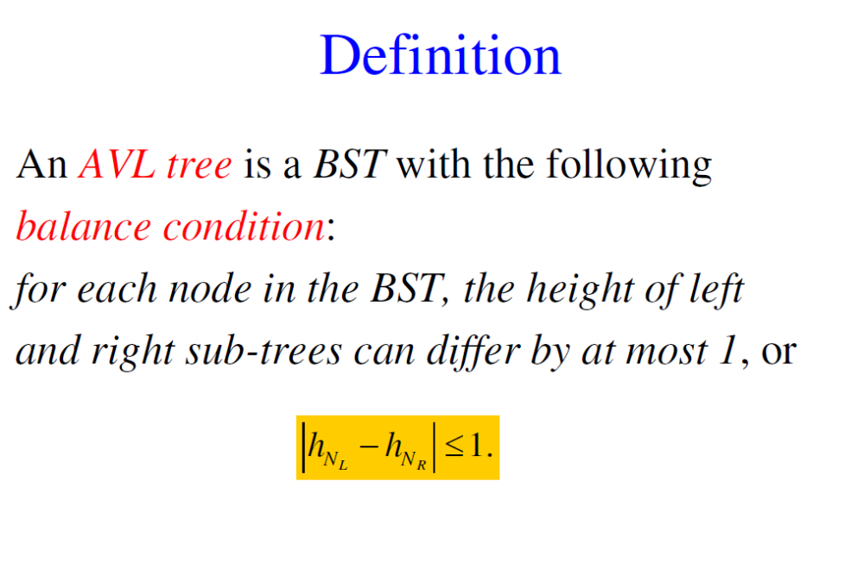

Q4. Final-2015 (15+10=25pts)
- How many different 6-node BST topologies, N_{total}, are there? Draw an example topology to characterize each topology group (a topology group signifies all BST topologies with the same number of nodes at each of its depth levels) and show your calculations that lead to your result!

  - Which among those in (Q1a) are already AVL tree topologies?
  - Apply the necessary rotations, stating 1. the α-node, 2. type of problem, 3. the type of necessary rotation, only to those topologies in (Q1a) that can be converted to an AVL tree at one rotation (single or double)?

5.)Quiz-2016 Construct a BST for the following sequence. (4 points)

30, 10, 94, 3, 99, 48, 59, 100, 51, 80, 77, 85, 78

Splay the node with key ”78” (30 points)

6.) Quiz-2015 (30 points)

Construct a BST from the letters ”MACHINE LEARNING” where no duplicate letters are allowed.

Splay the node ”L”. (Show all your work with)

Q7. FİNAL 2014 (10+15=25pts) (HOME EXERCISE)
Assume an AVL tree topology of height 6 (from depth level 0 to 5) with a minimum number of nodes.
- How many such binary tree topologies (not only AVL tree topologies but also those ) are there provided that the number of nodes at each depth level remains constant? Show one sample AVL tree topology.

- How many binary tree topologies (NOT AVL tree topologies) are there with the same total search time or internal path length?

